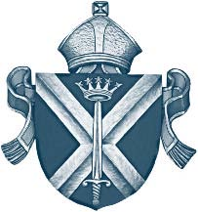
Diocese of St. Albans

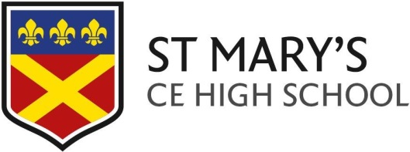

17 June 2019

Dear Parent/Carer

Year 10 Work Experience (10th – 14th February 2020)

In Year 10 all students are given the opportunity to take part in a week of work experience. We would like all of our students to gain a meaningful experience from their placements.
Students are encouraged to find their own Work Experience placements by contacting employers in industries that interest them or support their career aspirations. This not only provides them with a valuable insight into the job search process but can also help develop their confidence.
We work very closely with YC Herts who oversee the placements and also provide some placements for those that are unable to secure their own.
In order to give students ample time to think about their choices and the type of employer they wish to work with, I have enclosed an Own Placement Form which must be completed by those wishing to arrange their own Work Experience. This form must be signed by the Employer and returned to the school by w/e 13th September 2019.
Thank you in anticipation of your support. If you have any queries concerning any of the above, please do not hesitate to contact me.

Yours faithfully

C Scarisbrick
Miss Claire Scarisbrick
Lead Careers Education (CEIAG)

