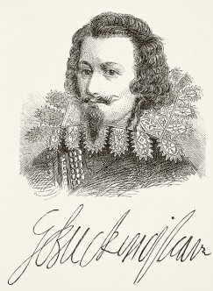

Listen to the podcast below and fill in the sheet:

<http://cdn.immediatecontent.com/bbchistory/audio/HistoryExtra_2017_08_31.mp3>

Death of James

Role of favourites