PHYSICS

Holiday practice work and reading list
Answer these questions on separate paper. This work is due on your first day back. Questions in bold are extension questions, and are meant to be challenging.

The reading list at the back of the booklet provides some choices of holiday reading. You should read at least one of these books during your summer break.

Many of the laws of physics that you will be learning about manifest themselves in the form of relationships between variables and equations. You will need to be able to rearrange equations and substitute quantities into these equations confidently.
- Using the equation $V=IR$ , calculate:
  - $V$, if $I=10$ and $R=2$
  - $R$, if $I=4$ and $V=$8
  - $I$, if $V=5$ and $R=0.25$

- Using the equation $s=ut+\frac{1}{2}at^{2}$, calculate:
  - $s$, if $u=6$, $t=3$, and $a=-1$
  - $t$, if $s=120$, $u=0$ and $a=2.4$
  - $t$, if $s= 3$, $u=2.5$, and $a=1$. (Extension question)
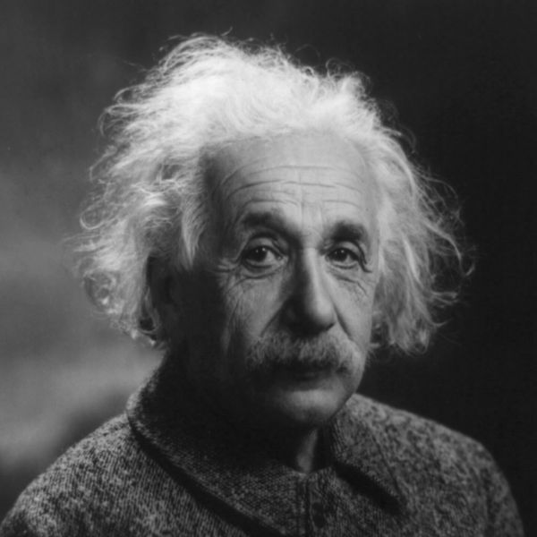
The speed of light is one of the fundamental constants of the universe, and was an essential constant in Einstein’s theories of general and special relativity.
- The speed of light is approximately $2.998×{10}^{8}$ metres per second. How far can light travel in
  - 40 seconds?
  - 5 minutes?
  - 1 day?
  - 1 year?
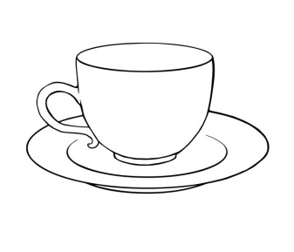
Water, otherwise known by its chemical formula $H_{2}O$, is an essential component of life on Earth, with unique properties that affect the climate, ecosystems, and cups of tea.
- One atom of Hydrogen has a mass of $1.67×{10}^{-24}g$, one atom of oxygen has a mass of $2.66×{10}^{-23}g$.
  - Which atom is the heavier?
  - What is the difference in mass between the two atoms?
  - One molecule of water is made up of 2 atoms of hydrogen and 1 atom of oxygen. What is the mass of one molecule of water?
  - A glass of water contains 250g of water. Calculate how many molecules of water are in this glass. (Extension question)

- A 6 m long ladder is placed against a wall as shown in the diagram below. The ladder makes an angle of ${60}^{o}$ with the floor.
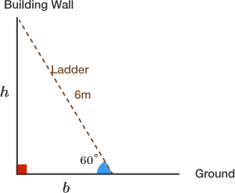
  - Calculate h, the height of the wall.
  - What angle should the ladder make with the floor to reach 5.4 metres up the wall?

- A learner records the time it takes for a ball to roll down a slope, and obtains the following values:
1.23s 1.30s 1.18s 1.18s 1.25s
  - Calculate the mean value.

During your physics course you will be writing a class test on each subsection to check your knowledge of the concepts covered. These tests occur every fortnight. You are expected to revise, even if only briefly, before each of these tests.
- James writes a physics test and obtains a mark of 29 out of 35.
  - Calculate the percentage mark that he obtained.
  - If James obtains a mark of 31 on his next test, calculate the percentage increase in his mark.
  - James is aiming for a mark of 80% overall for his end of year assessment. He gets a mark of 70/100 for paper 1, and 80/100 for paper 2. What mark out of 70 must James get for paper 3 to obtain an overall mark of 80%? (Use you induction notes to answer this question) (Extension question)

- Convert the following quantities:
  - $6 cm$ to $m$
  - $0.54 km$ to $mm$
  - $30 {cm}^{2}$ to $m^{2}$
  - $50 dm^{3}$ to $cm^{3}$
  - $520$ megabytes to gigabytes
  - 2.2 terabytes to kilobytes

BONUS QUESTION
- An architect has been commissioned to prepare a design for a large square of 150 by 150 m. In the middle of the square, there is a large fountain of 20m diameter. Dotted around the square are trees and benches. The cobblestones are nearly square but vary in length between 10 and 30 cm with an even distribution of sizes. Give an estimate of the number of stones that are used on the square.

Reading list
Genius: The Life and Science of Richard Feynman
by James Gleick

Electric Universe: The Shocking True Story of Electricity
by David Bodanis

Black Holes, Wormholes and Time Machines
by Jim Al-Khalili

QED: The strange theory of light and matter
by Richard Feynman

In Search of Schrodinger’s Cat
by John Gribbin

A brief history of time
by Stephen Hawking

A short history of nearly everything
by Bill Bryson

The accidental universe
by Alan Lightman

E=Mc2: A Biography of the World's Most Famous Equation
by David Bodanis

