Psychology Transition Work
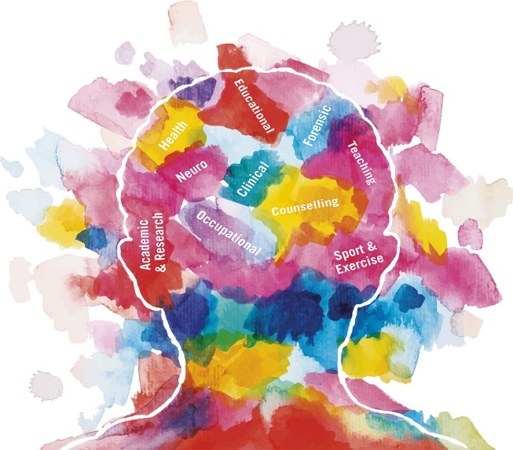
Task 1 : Is Psychology a science? A question that has been debated for years! Your task is to address the question in an essay style response. You should aim to cover 2 arguments that support it is a science and 2 arguments suggesting that psychology is not a science. You should then write an overall conclusion based on your research findings. In order to complete this task you will need to research the question (e.g. internet research).
Task 2 : A level Psychology involves learning a lot of research studies! You need to know how studies are conducted, what the studies support/refute and be able to evaluate the research studies you learn about.
The following website: http://bps-research-digest.blogspot.com is an excellent resource for Psychology students. This brilliant blog is updated fortnightly and features featuring cutting edge psychology research. Your task is to:
1) Go to the website and find an interesting piece of research – this can be on anything (as it is all psychology). You should read at least 3 different pieces.
2) On one A4 sheet of paper (this could be on the computer or handwritten) summarise the research that interested you the most. Include - The research area - How the research was conducted - What was found - Why this interested you - Anything else that you feel is relevant
You can present your work however you like (e.g. poster, mind map, notes).
Please do not just ‘cut and paste’: you need to present your research on 1 piece of A4 paper (this can be typed or by hand) you need to engage with your chosen piece of research.

