Sports Studies Transition Work
As well as working through the following booklet of information and PPT, please use the following links to access transition work and provide Mr Hunt (rosco.hunt@st-maryshigh.herts.sch.uk) so that he can set up access to The Everlearner platform which provides excellent resources to help you get a head start.
https://www.bbc.co.uk/bitesize/topics/zxq7j6f
https://www.youtube.com/watch?v=S-TE_3iYBCk&list=PLcdQDUUQX_4vcifsRu-iOyqZsxtlOsWxy

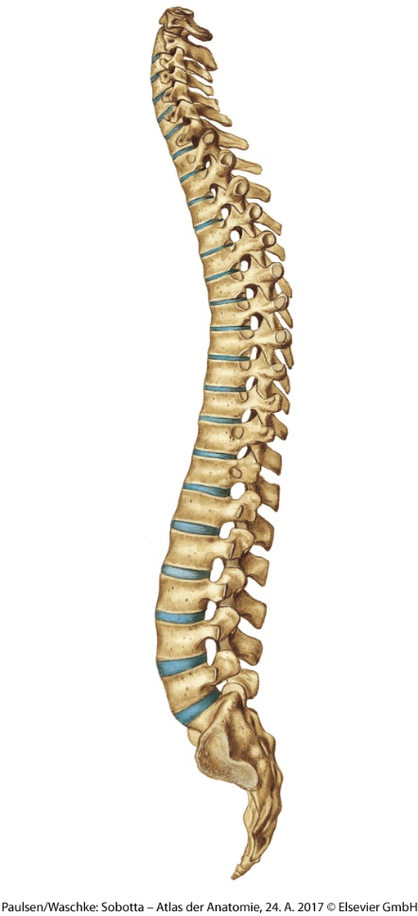
The Spine
On your Visual Guide, draw out an image of the spine. Label the cervical, thoracic, lumbar, sacrum and coccyx and make a note of how many vertebrae are per section.

Using a QR Code App, scan the following QR Code:

In relation to the GIF, answer the following questions:
- What is the agonist muscle in the dolphin kick? (Hint – E_____ S_____)
- Name two roles for the spine.
- Take a look at the structure of the vertebrae. What type of bone are they?
- What separates/sits between the vertebrae?
- Therefore, what type of joint is the spine? (synovial/fixed/cartilaginous)

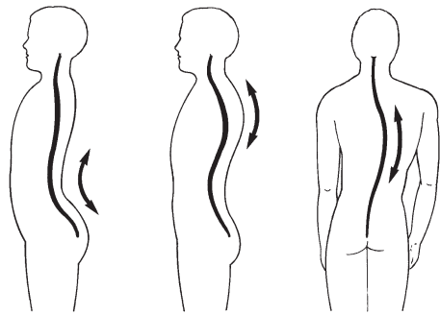
Factors Affecting the Spine
Draw the curvatures on your Visual Guide. Note down the name of each postural deviation.
Considering the GIF, how would each postural deviation affect the swimmer?

Bone Health and Formation
Take a moment to remind yourself and make a note of the following terms:
Bone Remodelling, Ossification, Diaphysis, Epiphysis
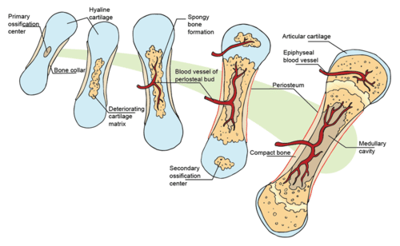
You, the Coach
You have been employed as a youth coach and are responsible for coaching under 12 academy footballers.
Consideration 1: What types of training should you be cautious around, and why?
Consideration 2: A player previously broke his femur. Since then he has developed uneven length legs. Why might this be? What would you advise the player?

Osteoblast | Osteoclast
What is the role of an osteoblast? In what ways would it help a footballer? | What is the role of an osteoclast? How does it help the osteoblast?

Get yourself over to Search for ‘Top 10 Dunks of The Decade’ (Posted by NBA 7 months ago). When you’re watching consider and make a note of the impact of exercise on the SKELETAL SYSTEM. Use the below visual organiser to help you remember
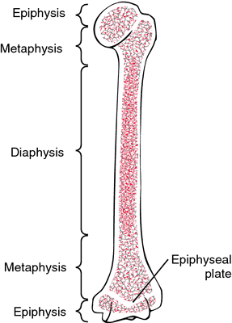
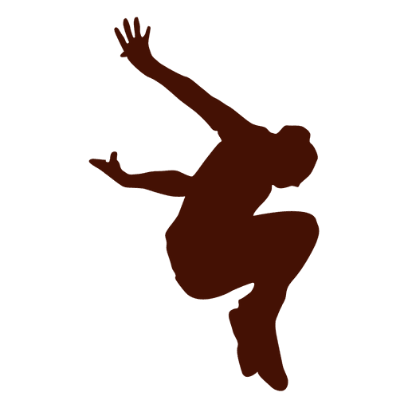
Ca
Ca

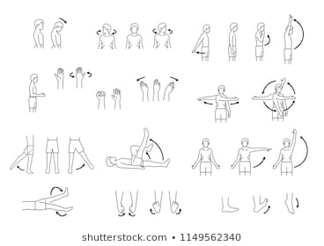
Joints
Create a rendition of a lunge where all ranges of movement occur:
Adduction, abduction, flexion, extension, hyperextension, lateral flexion, plantarflexion, dorsiflexion, rotation, circumduction, horizontal adduction/abduction.
Record and narrate your lunges with the types of movement and send them on an email to me.
Types of synovial joints
Scan the QR Code and draw out types of joints on your Visual Guide. Give an example of when it would be used in a sporting context. (Note: an ellipsoid joint is a condyloid joint)

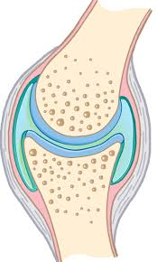
Synovial Joint
Draw out the synovial joint on your Visual Guide and note down the function of the following:
Bursa, Cartilage, Synovial Membrane, Synovial Fluid, Joint Capsule
You, the Coach

You have been recruited as an U23 PL Club physiotherapist. Some senior players have returned from injury. Explain to the players why warming-up is important for the synovial joints and how it will help their performance and recovery.

Muscles

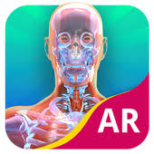  Android users - Download the app ‘Yourbody AR’. Aim it at the marker sheet. | Apple users – Download the app 'BioDigital Human 2019’. Explore the Muscular System

- Using the apps above, break the body down in to four parts on your Visual Guide sheet: Arms, Legs, Anterior (front), and Posterior (back).
- Give an example of one sporting action that uses that part identifying the following:
  - Agonist, antagonist, fixator, synergist

Fibre Types
Kipchoge | Highlanders v Chiefs | Eddie Hall
Watch each of these videos and make a note of the dominant fibre type for each sport. What are the characteristics of the fibre type: fuel/energy source, size, duration, intensity, and recovery?

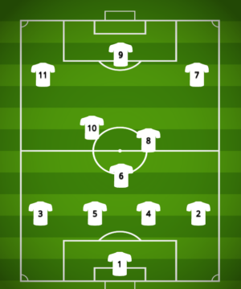
Creating the Perfect Team
Using whatever formation you want, assign muscle fibre types to each position of your perfectly fit football team. Feel free to add percentages for each position. For example, 30% Type 1, 60% Type 2a, 10% Type 2x.
Considerations when making decisions: Movements of the position, intensity of actions, recovery time, long-term adaptations

Muscles in Action
Perform a wall hold. On your Visual Guide draw this out and make a note of the type of contraction. What is the waste product building up? What would the long-term adaptation be to this type of training?
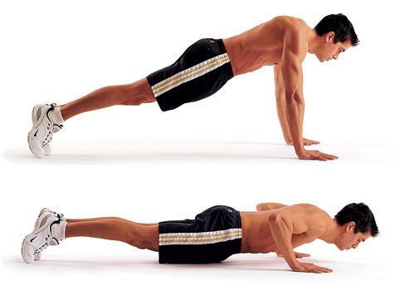
Next, perform super slow press-ups. Take 8 seconds going down slowly and 1 second up. Do 6 reps (why 6?). Draw this out on your Visual Guide, noting the type of contraction. What would be a short-term effect of this type of training and why? What would be the long-term adaptation of this type of training?

Energy usage and adaptations
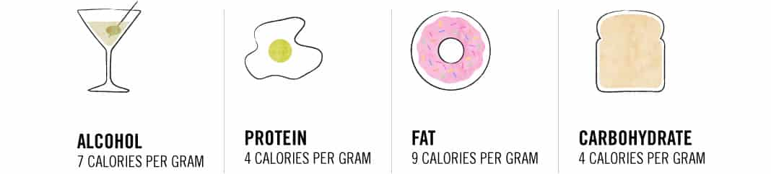
Take a look at the amount of calories per gram above. Which macronutrient would help an athlete last longer in their sport and why? With that in mind answer the following– true or false: a long-term adaptation to exercise is increase in storage and use of fats.
You, the S&C Coach

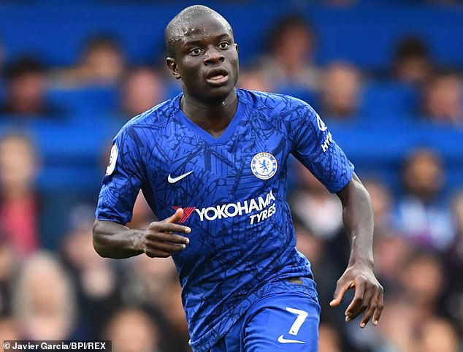
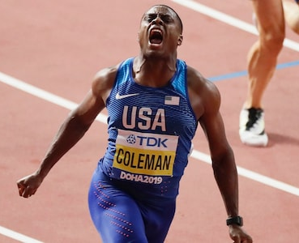
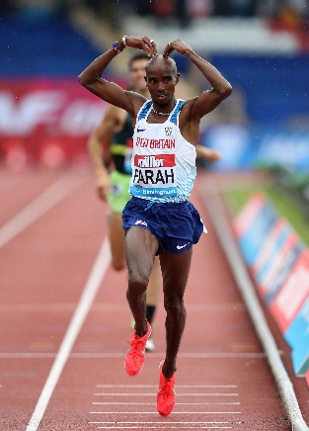
What are the long-term muscular adaptations for each of these athletes?

Respiratory System
Get on to Search for ‘How Altitude Works’
On your Visual Guide, draw a mountain and note down the adaptation to altitude training.
Using your newly found knowledge scan the QR code and explain the effect of exercise and altitude training on the RESPIRATORY MUSCLES >>>>>>>>>>

In the last World Cup, Golovin averaged 12.6km per game. What respiratory adaptations has he benefitted from that allows him to complete such great distance per game?
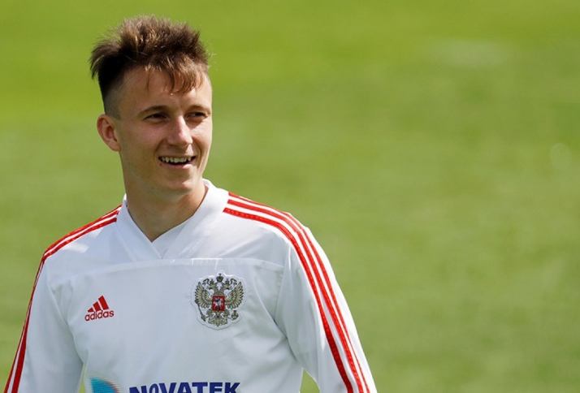
My favourite thing for breakfast is a yo-yo test
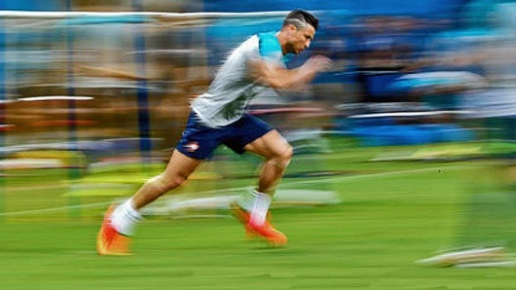
However, C-Ron peaked the top speed for the tournament at 34 km/h. Linking in to Lung Volumes, what changes would we observe with Ronaldo. Also, y tho?

The Structure of the Respiratory System
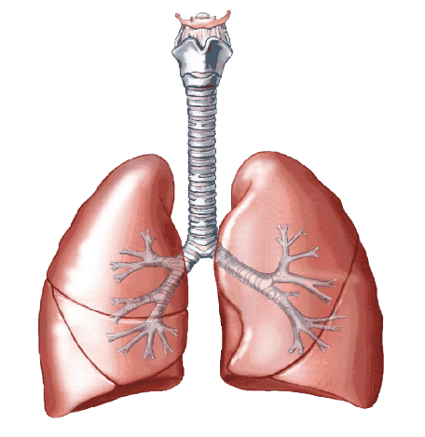
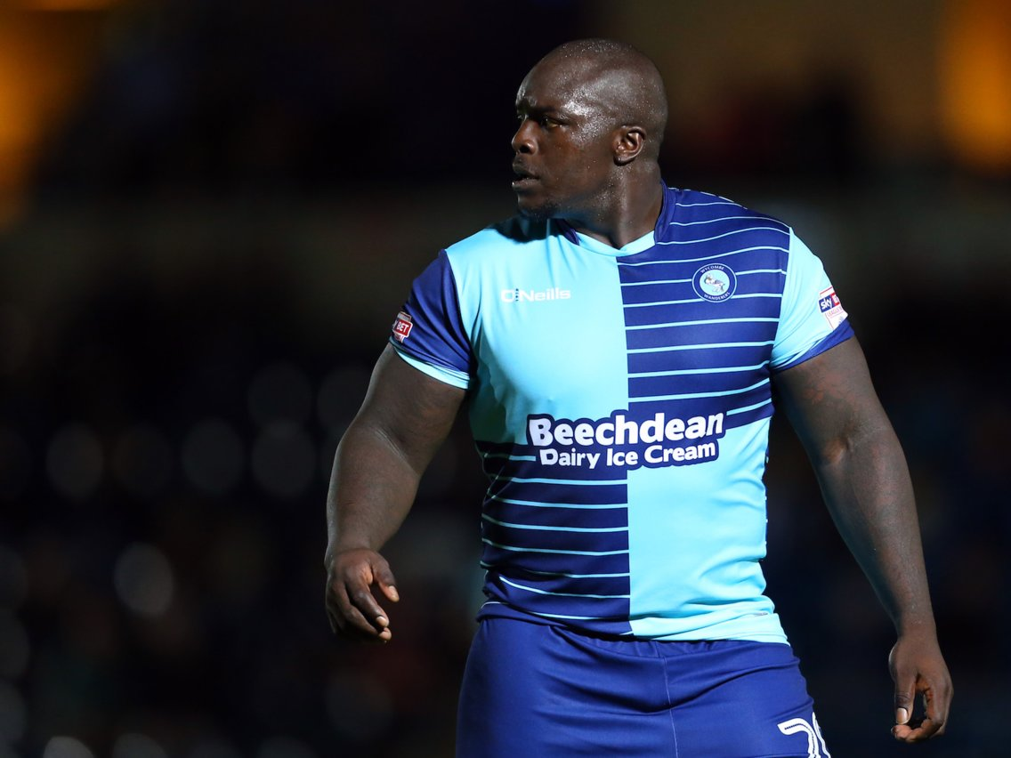
Akinfenwa looks confused at the structure of his respiratory system. Create a STORY of the passage of air as you inhale and expire the air back in to the atmosphere.
Akinfenwa likes creativity. BE CREATIVE
Note: Akinfenwa likes muscles. Be sure to tell him all about the RESPIRATORY MUSCLES involved in breathing too and how they work with inspiration and expiration.

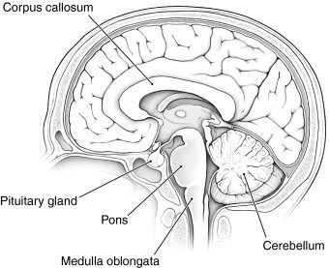
The Medulla Oblongata is responsible for controlling our breathing and communicatess with chemoreceptors in our carotid arteries and aortic arch.

On your Visual Guide, identify where the carotid artery and aortic arch is, explaining the signal they send and the overall effect on breathing

