You can use a calculator to produce words when you get an answer to a sum. Just turn the calculator upside down.

Can you find these ‘four-letter’ words?

e.g. 7 x 5 x 20 + 3² + 1 = 700 + 9 + 1 = 710 = O I L

Remember: 25 is worked out as 2 x 2 x 2 x 2 x 2 = 32 etc.

Can you find these ‘four-letter’ words
 | Sum | Answer | Word |  | Clue
1 | 7 × 10 × 100 + 2 × 9 × 41 | 7738 | Bell | You can ring this one.
2 | 5 × 7 × 13 × 17 |  |  | Sounds like above.
3 | 27× 100 + 27 × 67 |  |  | What a gasp!
4 | 5 × 1000 – 17 × 5 |  |  | ‘… of relief’
5 | 5 × 11 × 100 + 2³ - 1 |  |  | It was not a win. It was a …!
6 | 2 × 3 × 30² + 6 ×19 |  |  | The sound from a snake
7 | (2 + 3) × 11 × 10² + 9 - 1 |  |  | The person in charge.
8 | (2 + 3 + 4) × 50 × 10 |  |  | ‘Loads a …’
9 | (1 + 2 × 3) ÷ 40 |  |  | I… On the ice.
10 | 13 × ( 4 × 10² + 3²) |  |  | The truth, not …
11 | 3 × 5 × 13 × (3³ – 2³) |  |  | Fits on a shoe
12 | 3 × (23 × 50 + 9³) |  |  | Fits in a shoe (twice)

Can you find these ‘five-letter’ words
13 | 30 × 1000 + 5 × 35 |  |  | What you can do on ice.
14 | 3 × 10000 + 2 × 10² – 3 × 7 |  |  | Almost the same on water!
15 | (5 × 10 + 5) × 10³ + 2 × 89 |  |  | Get it right; it’s sheer …
16 | 3⁵ × ( 2 × 100 + 7 × 5) |  |  | Makes a mess!
17 | 3 × 19 × ( 500 + 5 × 10²) + 108 |  |  | What the water does in a kettle
18 | 5 × (10 + 1) × 10³ + 3⁴ - 2 |  |  | It’s a type of paint or lip …
19 | 5.3 × 10⁴ + 13² × 3 |  |  | Newcastle nearly always … MU
20 | 3.5 × 10⁴ + 2⁴ - 7 |  |  | A ‘gobby’ flying bird.
21 | 3.5 × 10⁴ + 18² + 3² + 3 |  |  | More of these ….
22 | 2 × 3 × ( 10³ + 17²) ÷ 1000 |  |  | Nice to see you.
23 | (29² – 2 × 5²) / 10⁴ |  |  | This is made of ice
24 | (2² + 1)(3² + 2)(6² - 5) ÷ 10⁴ |  |  | Not soft but ….

Can you find these ‘six-letter’ words
25 | 7² × 11 × 10³ |  |  | He the ball
26 | 2 × 41 × (6000 + 23² + 2³) |  |  | You trim these with sheers
27 | 5 × (7² – 2³) × 181 ÷ 10⁵ |  |  | Dirty …
28 | 4 × 10⁻³ × (9 × 10³ + 277) |  |  | Fried or …
29 | 5³ × (60² +10² – 3²) |  |  | Santa’s …
30 | 577000 + 19² - 4² |  |  | She sells … on the sea shore
31 | 5⁸ + 5³ - 5² – 5 - 2 |  |  | Ships muck or waste
32 | 2⁵ × (107² + 2⁵ × 10) |  |  | The mind it … but without the ‘s’
33 | (27² + 2²)² + (2⁴ + 7)² |  |  | Read by majority of Christians
34 | 31² × 32² – 276² + 5² + 5 |  |  | Not a twig

Can you find these ‘seven-letter’ words
35 | 48⁴ + 13⁴ + 2⁶ × 3 × 5 |  |  | Not a … to stand on - almost
36 | 2²⁰ × 5 + 273² - 4³ |  |  | Two words – she’s not trusting
37 | 7⁸ – 5⁸ + 2⁷ × (1 + 3 ×6) |  |  | The mind …
38 | 3 × 6⁸ + 2¹⁸ + 281² – 4 × 11 |  |  | Swim with these.
39 | 2³ × 7 × 67 ×(6⁴ +11² + 2⁴) |  |  | She finds it funny.
40 | 48⁴ – (9⁴ + 17² + 3³ + 1) |  |  | It’s … the point!
41 | 5³ × 17 × (2 × 10³ + 2⁷ - 2) -1132 |  |  | How large?
42 | 180³ – (240 + 2)² + 10² - 2 |  |  | … sweets at the shop
43 | 22⁵ + 383² + 3 + 3 × 7 |  |  | Will she or won’t she?
44 | 2301 × 2309 + 3⁴ ×(4³ - 3³) |  |  | Searches on WWW

And finally. Try these sentences!
 | 18⁷ + 7⁸ + (1 + 2 × 3²) × 3700 + 1 |  |  | Is he biggish?
 | 17⁸ + 42⁵ – 916 × 969 - 35 |  |  | The gardener.
 | 17⁷ – 47⁴ + 2 × 31 × 41 |  |  | Oh good grief
 | 5.3 × 10⁸ + 5 × (4³ + 3) × 103 |  |  | Has she done it.
 | (5 × 108 × 112 + 5²) ÷ 10⁷ |  |  | How was your ice cream?
 | 3 × 7² × (78² + 7²) ÷ 10⁸ |  |  | … Yes Sidney is great
 | 2²⁹ – 11⁶ - 161² - 5² |  |  | It’s a result!
 | (4¹³ – 1413 × 1414 – 3⁶ – 19) ÷ 10⁹ |  |  | She is almighty
 | 318³ – 2² × 11 × 10² + 13 |  |  | What …. Are your feet?
 | 7⁹ + 2175² + 2 × 11 × ( 1 + 3 × 4) |  |  | …. Doosh not dosh!

Philip’s calculator word exercise

Below are ten sums for you to do on a calculator. Each answer will represent a word when the calculator is turned upside down.

e.g. 7 x 10 x 10 + 2 x 5 = … 710 … which stands for… O I L.

Complete the story that unfolds below by filling in the gaps with the appropriate word.

2 x 15 x 15 x 2 + (1 + 2 x 3 x 3 ) + 19 = | 3 x 2 x 5 x 100 + ( 2 x 2 x 2 -1 ) x 100 + 4 =
( 1 + 1 ) ÷ ( 2 x 2 x 2 + 3 x 3 ) = | ( 1 + 1 ) x 1125 x ( 1 + 1 ) =
2 x 567 ÷ ( 5000 + 5000 ) = | ( 1 + 1 x 1 ) ÷ ( 2 x 5 x 5 x 2 ) =
25 x 40 + 2 x ( 2 x 30 + 7 ) = | ( 2 x 10 + 10 ) x 100 + ( 2 x 3 + 1 ) x 100 =
( 29 × 29 -10 × 10 ) x 5 = | 2 x ( 2 x 5 + 7 ) x ( 2 + 15 x 15 ) =

! My name is Phil. It is without especially when you are on
the .When I do get some money it always burns a in my pocket. My friend
is called . says I should save more. I sometimes have to for
money to go to the . When I got back from one of my visits my trainer had lost its-
because a lion had eaten it!

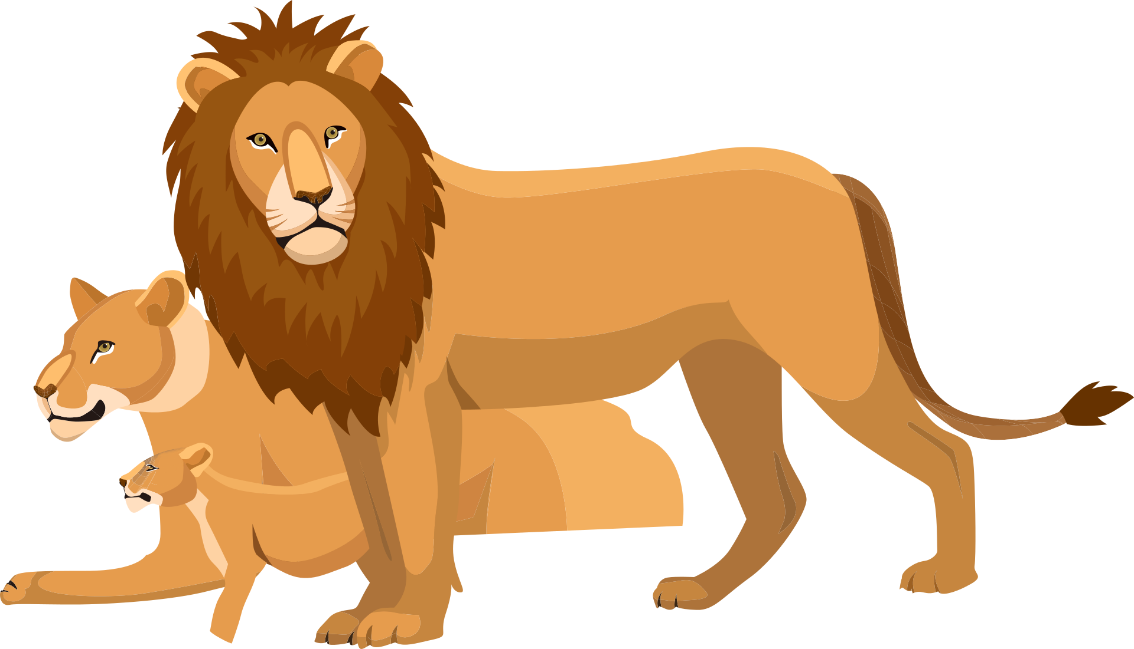

Answers

- 7735 (bell)
- 4509 (gosh)
- 4915 (sigh)
- 5507 (loss)
- 5514 (hiss)
- 5508 (boss)
- 4500 (dosh)
- 175 (slid)
- 15317 (lies)
- 3705 (sole)
- 5637 (legs).
- 30175 (slide)
- 30179 (glide)
- 55178 (bliss)
- 57105 (soils)
- 57108 (boils)
- 55079 (gloss)
- 53507 (loses)
- 35009 (goose)
- 35336 (geese)
- 0.7734 (hello)
- 0.0791 (igloo)
- 0.1705 (solid).
- 539000 (dodges)
- 536034 (hedges)
- 0.37105 (soiled)
- 37.108 (boiled)
- 461375 (sleigh)
- 577345 (shells)
- 390718 (bildge)
- 376608 (boggle)
- 537818 (bibles)
- 907918 (big log)
- 5337937 (legless)
- 5317345 (she lies)
- 5376608 (boggles)
- 5379909 (goggles)
- 5376616 (giggles)
- 5301538 (besides)
- 4516618 (biggish)
- 5773534 (he sells)
- 5300345 (she does)
- 5316006 (googles)

Sentences

- 618055134 (he is so big)
- 7105561034 (he digs soil)
- 405461534 (he sighs ‘oh’)
- 530034505 (so she does)
- 0.0060505 (so so good)
- 0.00901551 (is sid good?)
- 535073405 (so he loses)
- 0.064110134 (heidi is god)
- 32153045 (shoe size)
- 45084518 (bish bosh)

Answers: Philip’s calculator word exercise:

938(beg)⁸
3704(hole)⁵
34(he)⁷
4500(dosh)³
0.1134(hello)¹
0.02(zoo)⁹
1134(hell)²
3700(dole)4
3705(sole)¹⁰
7718(bill)⁶

These answers follow the clues across the page:

938 (BEG)⁸ is the first answer which matches the eighth missing word

