BTEC Applied Science

Bridging Work Booklet
Pearson BTEC Level 3 National Extended Certificate in Applied Science (360 GLH) 601/7436/5

Table of Contents
Welcome note 2
Resources 2
Useful information 3
SI units 3
Prefixes 3
Biology section 4
Activity 1 5
Activity 2 6
Activity 3 7
Activity 4 8
Activity 5 8
Activity 6 9
Activity 7 9
Activity 8 10
Activity 9 11
Activity 10 12
Chemistry section 13
Activity 1 13
Activity 2 14
Activity 3 15
Activity 4 16
Activity 5 17
Activity 6 18
Activity 7 19
Activity 8 19
Physics section 21
Activity 1 21
Activity 2 21
Activity 3 22
Activity 4 23
Activity 5 24
Activity 6 25
Activity 7 26
Activity 8 27
Activity 9 28
Research Task 29
Data Sheet 30

Welcome note

Getting a good head start into what BTEC Level 3 National Extended Certificate in Applied Science is about will be the key to your success. This bridging work is designed to help you bridge the gap between your GCSE Science studies and BTEC Level 3 National Extended Certificate course. It includes a list of topics from GCSE that will be helpful for you to review and practice.
It is important that you complete all your assigned work in preparation to your new course. The work will help you develop necessary skills for post 16 studies such as resilience and time management that will be essential during years 12 & 13. In September, your bridging work needs to be handed at the first lesson and it will be assessed. This way we can diagnose your strengths and weaknesses and begin to support you in a more targeted way.
This booklet has 4 sections.

- Biology
- Chemistry
- Physics
- Research task

All sections need to be completed.

Resources

- There is a list of available resources plus valuable information as well as course specification in the Pearson’s website.
https://qualifications.pearson.com/en/qualifications/btec-nationals/applied-science-2016.html

- Royal Society of Biology https://www.rsb.org.uk/
- Royal Society of Chemistry https://www.rsc.org/
- Institute of Physics (IOP) http://www.iop.org/tailored/students/
- Free Science Lessons (You Tube) https://www.youtube.com/channel/UCqbOeHaAUXw9Il7sBVG3_bw

- BBC Bitesize https://www.bbc.com/bitesize/levels/z98jmp3

Useful information

SI units
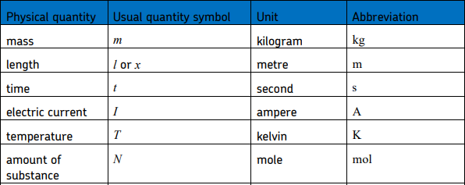

Prefixes
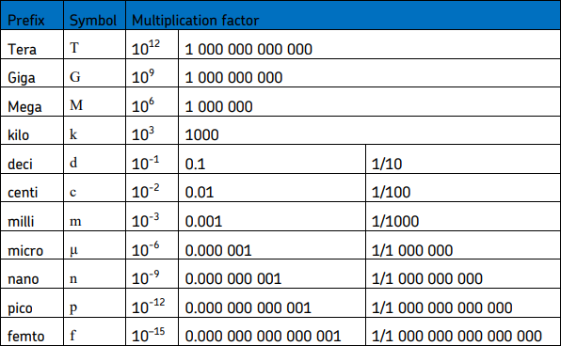

Greek letters
Greek letters are used often in science. They can be used as symbols for numbers (such as π
= 3.14…), as prefixes for units to make them smaller (eg μm = 0.000 000 001 m) or as symbols for particular quantities (such as λ which is used for wavelength).
The Greek alphabet is shown below.

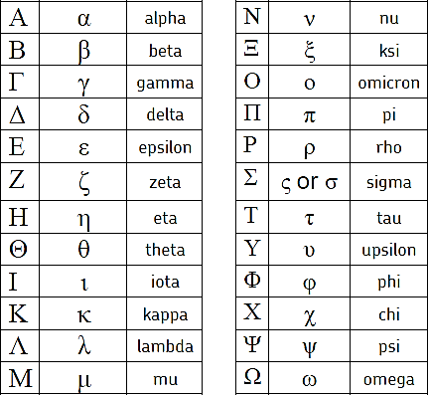

Biology section

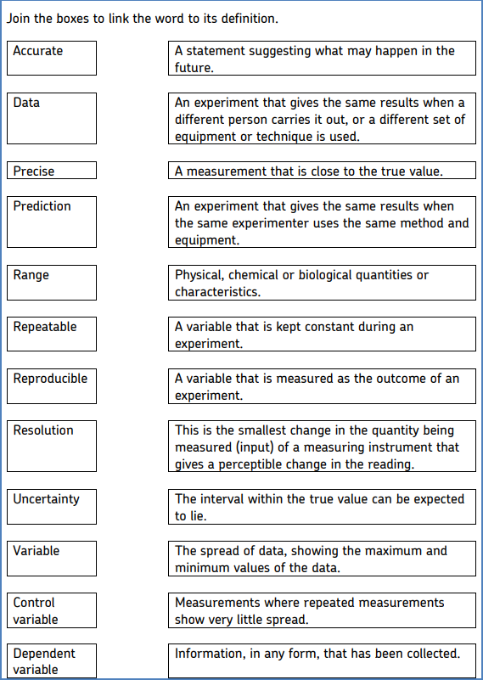
Activity 1

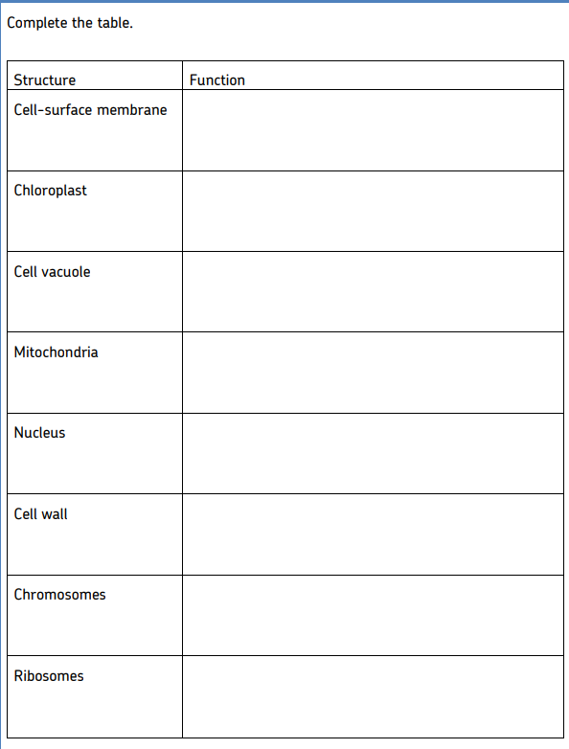
Activity 2

Activity 3
Draw the structure of a plant cell and an animal cell. On each cell, add labels showing each of the structures in the table, if they exist.

Activity 4
Label the organs in the body.
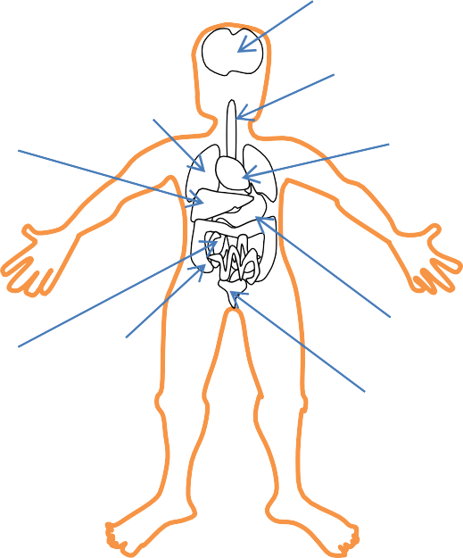

Activity 5
Complete the table to show which down the organ that carries out each function.

Organ | Function
 | takes oxygen into the bloodstream
 | breaks down (digests) food
 | make sperm cells
 | make egg cells
 | controls the body’s functions
 | absorbs nutrients from food
 | produce urine
 | sense light

Activity 6
Draw a line to match each organ system with the organs it contains.

Reproductive |  | ears, eyes, nerves
Digestive |  | stomach, intestines, pancreas
Circulatory |  | kidneys, liver, skin
Excretory |  | ovaries, uterus, oviduct
Sensory |  | heart, arteries, veins
Nervous |  | trachea, lungs, diaphragm
Respiratory |  | brain, spinal cord nerves

Activity 7
Complete the table.

Structure | Description | Adaptation for function
Rib
Alveoli
Bronchus
Trachea
Larynx
Diaphragm
Bronchiole

Activity 8
State the three types of blood vessels that make up the circulatory system.
•
•
•

State the name of the space which blood flows in a blood vessel.

......................................................................................................................................................

......................................................................................................................................................

Complete the table to compare the relative sizes and structures of the three types of blood vessels. Choose from the options in brackets.

Blood Vessel | Size of lumen  (very narrow/narrow/wide) | Thickness of wall  (thin/ thick/ very thin) | Do they contain valves?  (yes / no)
Arteries
Veins
Capillaries

Compare the function of arteries and veins.
......................................................................................................................................................

......................................................................................................................................................

Activity 9
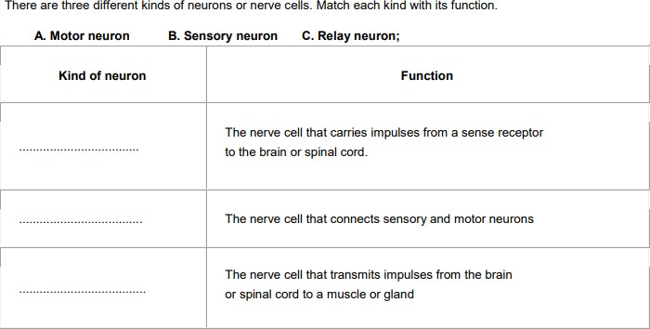
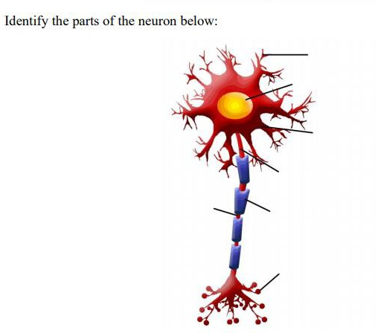

Activity 10
Summarise the structure and function of the heart.
......................................................................................................................................................

......................................................................................................................................................

......................................................................................................................................................

......................................................................................................................................................

......................................................................................................................................................

......................................................................................................................................................

......................................................................................................................................................

......................................................................................................................................................

......................................................................................................................................................

......................................................................................................................................................

......................................................................................................................................................

......................................................................................................................................................

......................................................................................................................................................

......................................................................................................................................................

......................................................................................................................................................

......................................................................................................................................................

......................................................................................................................................................

......................................................................................................................................................

......................................................................................................................................................

......................................................................................................................................................

Chemistry section

Activity 1

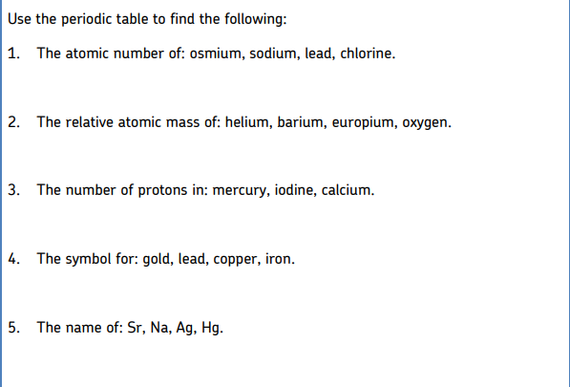

Activity 2
Relative atomic mass (Ar)
If there are several isotopes of an element, the relative atomic mass will take into account the proportion of atoms in a sample of each isotope. For example, chlorine gas is made up of 75% of chlorine-35 and 25% of chlorine-37. The relative atomic mass of chlorine is therefore the mean atomic mass of the atoms in a sample, and is calculated by:
𝐴𝑟 = (75.0/100 × 35) + (25.0/100 × 37) = 26.25 + 9.25 = 35.5

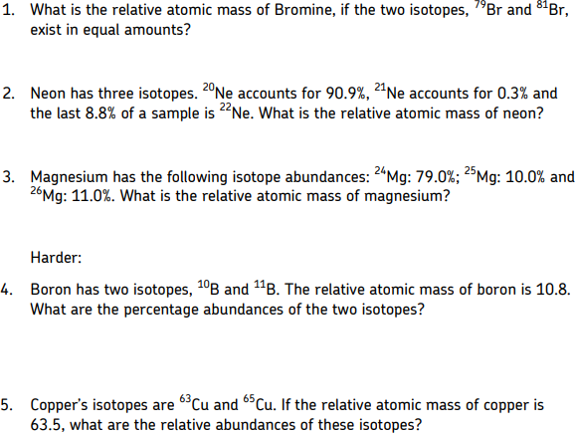

Activity 3
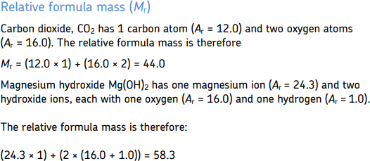

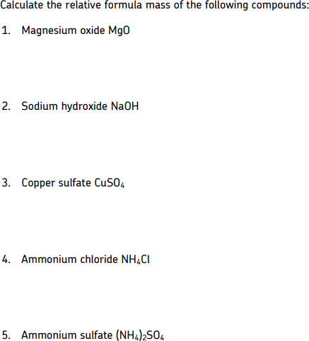

Activity 4

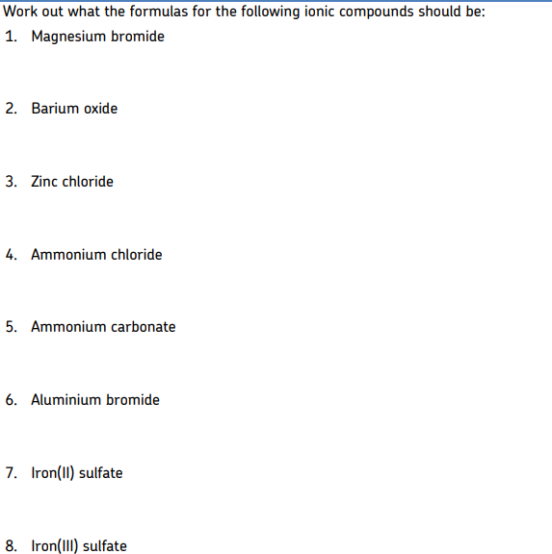

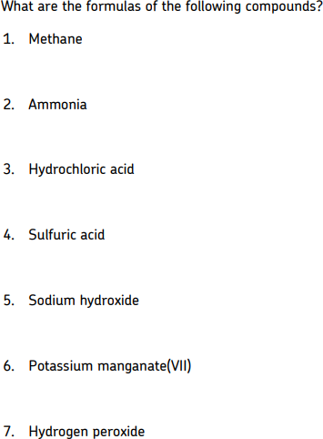

All metals form a positive ion, all non-metals form negative ions. The magnitude of the charge depends on the group number.

Draw the ionic bonding for each compound.

lithium fluoride | sodium fluoride | potassium fluoride | lithium chloride | sodium chloride

Draw a dot and cross diagram to show how the electrons are arranged in the following small molecules.

A. Hydrogen gas |  | B. Water
C. Carbon dioxide |  | D. Hydrogen chloride

Activity 8
Balance the equations below by adding numbers in front of the formulae – however, you must not change the formulae themselves!
Be careful as some may already be balanced.

e.g. 2 H + O → 2 H O
2 2 2
1 | HCl + Mg → MgCl2 + H2
2 | Na + O2 → Na2O
3 | Si + HCl → SiCl4 + H2
4 | TiCl4 + Mg → Ti + MgCl2
5 | Al + O2 → Al2O3
6 | HCl + Na2S2O3 → S + SO2 + NaCl + H2O
7 | C6H12O6 + O2 → H2O + CO2
8 | HNO3 + NaOH → NaNO3 + H2O

9 | K + H2O → KOH + H2
10 | Pb(NO3)2 → PbO + NO2 + O2
11 | NaOH + H3PO4 → Na3PO4 + H2O
12 | Pb(NO3)2 + AlCl3 → PbCl2 + Al(NO3)3

Physics section

Activity 1

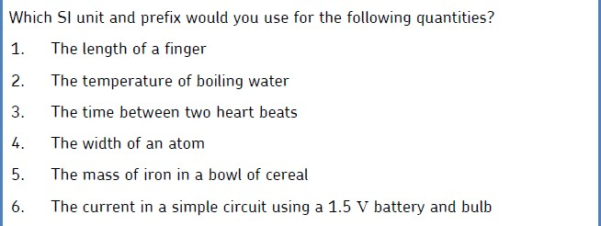

Activity 2

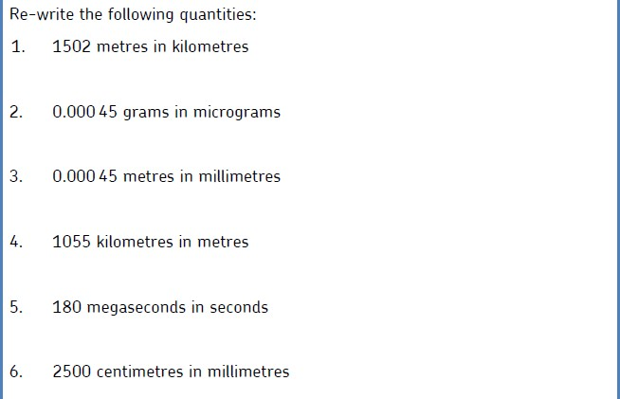

Activity 3

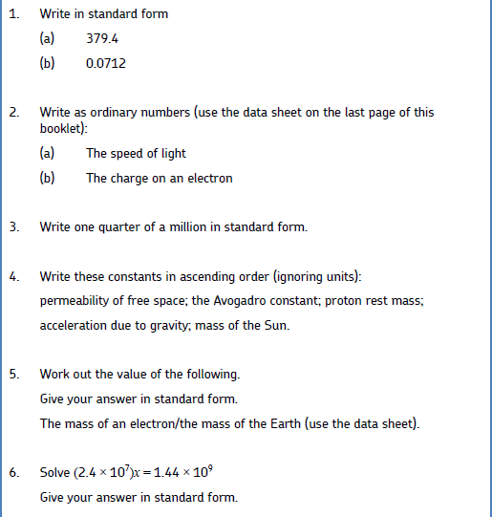

Activity 4

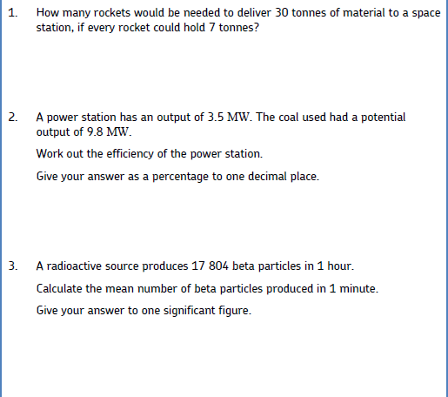

Activity 5

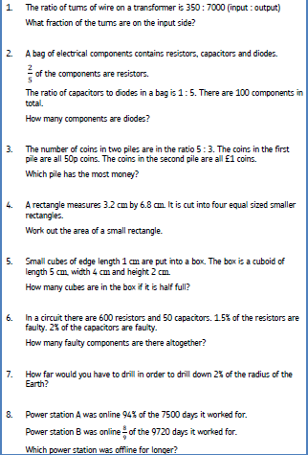

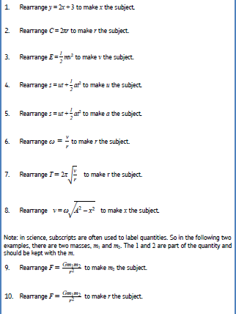

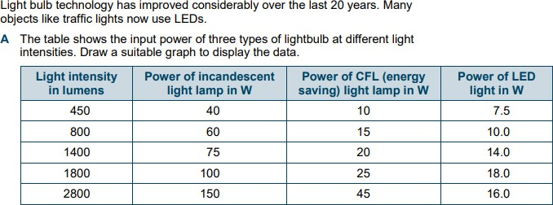

You can use your own graph paper or the space below –

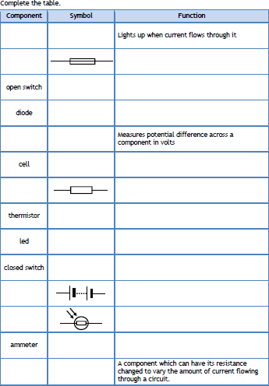

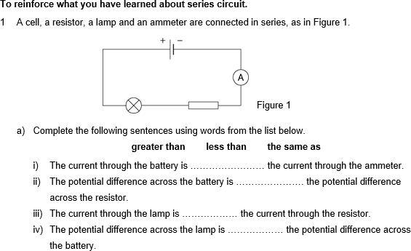

Research Task

All students need to create a scientific poster on one of the following topics.

- Cardiovascular diseases
- The Periodic Table
- Electromagnetic waves and their uses
All posters should be ready for display at the first lesson along with your completed booklets. The posters will be discussed among staff and students.
Poster Guidelines:
The dimensions of your poster should be min 90cm x 1m Please visit the following websites to help you with your poster. https://guides.nyu.edu/posters
https://www.youtube.com/watch?v=AwMFhyH7_5g

Have a lovely summer!

Data Sheet
Quantity | Symbol |  | Value | Units
speed of light in vacuo | 𝑐 |  | 3.00 × 108 | m s–1
permeability of free space | μ0 |  | 4π × 10–7 | H m–1
permittivity of free space | ε0 |  | 8.85 × 10–12 | F m–1
magnitude of the charge of electron | 𝑒 |  | 1.60 × 10–19 | C
the Planck constant | ℎ |  | 6.63 × 10–34 | J s
gravitational constant | 𝐺 |  | 6.67 × 10–11 | N m2 kg–2
the Avogadro constant | 𝑁A |  | 6.02 × 1023 | mol–1
electron rest mass | 𝑚e |  | 9.11 × 10–31 | kg
proton rest mass | 𝑚p |  | 1.67(3) × 10–27 | kg
neutron rest mass | 𝑚n |  | 1.67(5) × 10–27 | kg
gravitational field strength | 𝑔 |  | 9.81 | N kg–1
acceleration due to gravity | 𝑔 |  | 9.81 | m s–2
atomic mass unit | u |  | 1.661 × 10–27 | kg
mass of the Sun |  | 1.99 × 1030 | kg
mean radius of the Sun |  | 6.96 × 108 | m
mass of the Earth |  | 5.98 × 1024 | kg
mean radius of the Earth |  | 6.37 × 106 | m

