Economics Transition Work.
Economics is a two element subject. Microeconomics looks at how individuals (households, firms, Government) make choices about spending, saving, working, investing in the face of scarce resources. Macroeconomics looks at how the economy works as a system looking at aggregate values like total output, employment, inflation, the exchange rate, income distribution, the balance of payments. Please have a look at the link below – a crash course introduction into Economics:
https://www.youtube.com/watch?v=3ez10ADR_gM
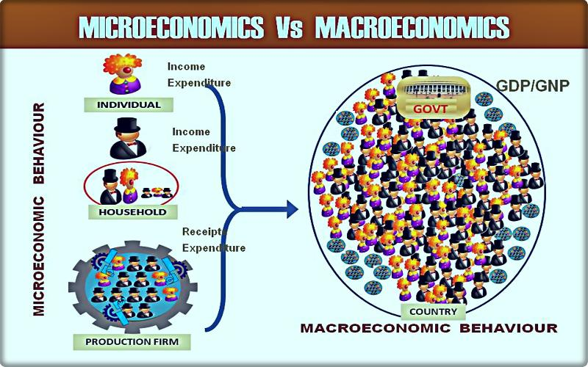

The project brief aims to introduce you to these two elements before you start working on the subject in September. It really will help. There are lots of new key terms to understand and make sense of and graphs to learn how to draw and experiences or stories about companies, groups of people (the poor) or countries or regions or the global economy is working and what to anticipate is likely to happen next. We are living through a unique moment in economic history which makes it all the more exciting and of course dreadful.
For an overview of the microeconomics side see:
https://www.tutor2u.net/economics/reference/as-microeconomics-study-notes-topic-listing
and macroeconomics side:
https://www.tutor2u.net/economics/reference/head-start-economics-introduction-to-macroeconomics
For the two projects below please read and make sense of the materials below and any other sources you like and create a short report on both sections in four parts:
- Definition of key terms e.g. oil price determination or welfare…
- Causes or influences section e.g. what influences oil prices?
- Consequences or outcomes happening or likely to happen in the future i.e. what impact are lower oil prices having on producers, consumers, countries which depend on oil exports for earnings and tax revenues e.g. Nigeria.
- Evaluation – what your explanation and conclusions depend on to be true.
Research Project 1: Evaluate the main influences on Oil price determination, outcomes and the welfare implications of volatile prices and currently very low prices in global markets.
Sources:
https://www.marketwatch.com/story/about-150-years-of-oil-price-history-in-one-chart-illustrates-crudes-spectacular-plunge-below-0-a-barrel-2020-04-22
https://www.tutor2u.net/economics/reference/falling-world-oil-prices-chain-of-reasoning-revision
https://www.tutor2u.net/economics/blog/oils-amazing-moment-as-crude-prices-fall-below-zero
https://www.tutor2u.net/economics/reference/evaluating-impact-of-lower-oil-prices
https://www.tutor2u.net/economics/blog/falling-oil-prices-and-the-energy-industry
Project 2: Evaluate Coronavirus-19 causes, the impact and welfare implications of locking down the economy to save lives and avoid overwhelming the NHS. See the Oxford Economics research paper separately provided.
https://www.telegraph.co.uk/news/2020/04/23/pandemic-coronavirus-covid-19-started/
https://www.bbc.co.uk/news/business-51706225
https://www.tutor2u.net/economics/reference/macro-policies-to-prevent-an-economic-depression
Please prepare your two reports for handing in during your first lesson in September.

