A Level English Literature: Transition Tasks

In order to prepare yourself for A Level English Literature you should complete the following tasks.
They will help prepare you for the course and ensure that you are keeping your mind active and engaged.
Create a folder where you can store all your research and completed tasks. Ideally this should be an electronic folder on your laptop. Label it English Literature and then you can create folders within the folder for each set text or task. When we return to school, you will have a ring binder/ folder to keep all the paper copies but your electronic folder will be an ongoing place to store essays and coursework.
Look at the English Department website to get a glimpse f what texts we will be studying:
KS5 Literature (weebly.com)

Task 1: Download the A Level specification and the glossary of terms into your specification folder:
https://www.ocr.org.uk/qualifications/as-a-level-gce/english-literature-h072-h472-from-2015/
Task 2: Once you have read the specification you can create three folders within your English Literature folder: Drama and Poetry pre-1900, Comparative and contextual Study and Literature post-1900.
Task 3: Drama and Poetry pre-1900: the set texts for this unit are Twelfth Night by William Shakespeare, A Doll’s House by Henrik Ibsen and Selected Poems by Christina Rossetti
Create a context folder for each of the three texts. You are to create a word document or PowerPoint with as much contextual information as you can find about each of the writers. This should include: the time that they were alive, the time that the set text was written, some information about their life, what was happening in society at the time that the texts were written? What other great literature was being written at this time in history? Can you find some examples of art inspired by the texts?
Task 4: Comparative and Contextual Study : the set texts for this unit are Frankenstein by Mary Shelley, Dracula by Bram Stoker and The Bloody Chamber by Angela Carter. They are all gothic texts. Research the term ‘gothic’. Create a mood board/ collage of images of gothic art from over the years. What are the conventions of gothic art? Look at the British Library articles about gothic literature. https://www.bl.uk/romantics-and-victorians/themes/the-gothic
Task 5: Create a timeline of events for Mary Shelley- writer of Frankenstein
Task 6: Create a detailed research document (can be written as a report or a PPT document) on Angela Carter. Please include the following areas: her life, her writing, her impact on other forms of writing such as theatre and film.
https://www.bl.uk/20th-century-literature/articles/angela-carter-gothic-literature-and-the-bloody-chamber
Task 7: Explore the impact of Dracula on popular culture. Create a collage/ mood board of front covers of the novel. What common conventions do you see? Write a ‘before I read’ about the novel. What themes do you expect to encounter? Write a brief summary of what you think the main narrative is.

Task 8: Look for an audio version of Dracula. This can be found on YouTube or Audible. Audible are doing free audio books for students during lockdown. Listen to the novel. It will help the reading of the text and it is very atmospheric. Who is the main narrator of the novel?
https://www.youtube.com/watch?v=3mVW8F1b8Qc&list=PLe4Qm8CPlS2TIUHFhNAA6i8S1LBX8YHzT This is the first section but the rest is all on YouTube

Task 9: Mini Essay: What is the literary canon? Which writers can be considered part of the literary canon? What is the purpose of the literary canon and what ae the negative connotations of it?
Task 10: Critical theory (AO5) is an important part of the A Level English literature mark scheme and offers Literature students alternative interpretations. Return to the exam specification and look at the breakdown of marks based on Assessment Objectives. Look at how each of the Assessment Objectives (AOs) are weighted. Can you say what each of the AOs are expecting from you? What do you have to do to do well with each AO?

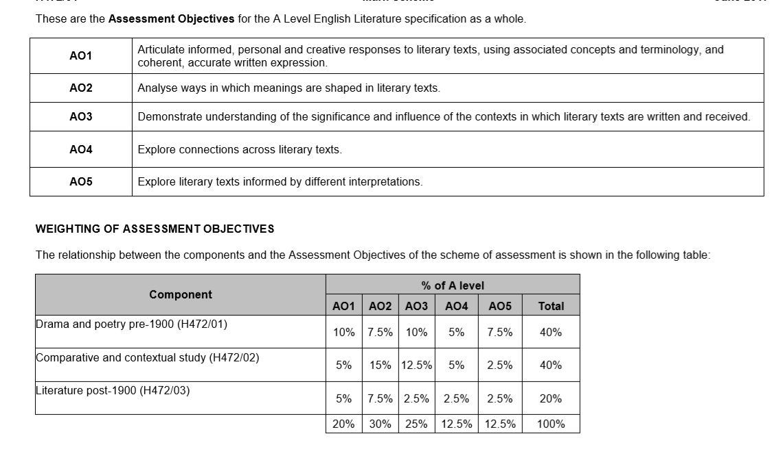
Try and read as many of the set texts as possible before the start of the course! It will help with your work load and allow you to focus on the fine details later. Some of the texts can be found as pdfs online (Dracula, Frankenstein, Twelfth Night, A Doll’s House) Aim to read other gothic texts to improve your wider knowledge (The Turn of the Screw, Wuthering Heights, The Picture of Dorian Gray, The House of Usher).

