Transition Pack
A Level Geography
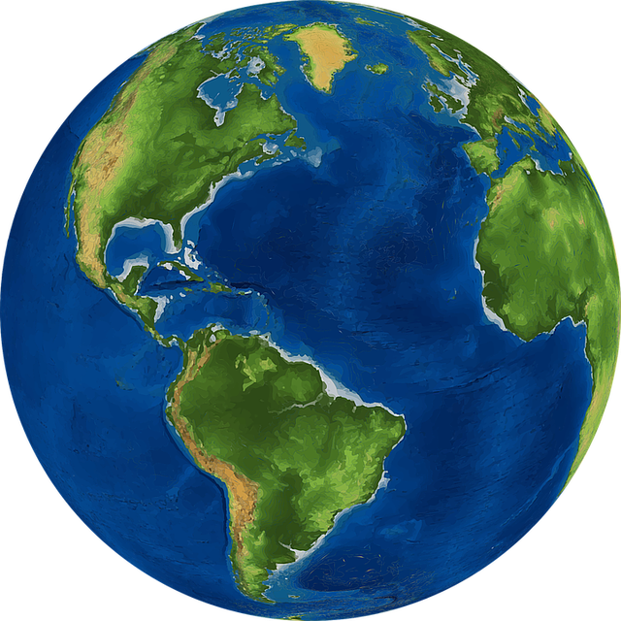
2021

Name: _________________________________________

Tectonic Processes and Hazards
Enquiry Questions:
1. Why are some locations more at risk from tectonic hazards?
2. Why do some tectonic hazards develop into disasters?
3. How successful is the management of tectonic hazards and disasters?

This topic develops your knowledge from GCSE. Use the information below, your own knowledge AND additional research to complete the tasks below.

Plate Boundaries

1. For each plate boundary identify the different tectonic hazards to be found and the key features.
Plate boundary | Earthquakes and/or volcanoes | Key features (direction of plate margin, type of plate,
Destructive
Constructive
Collision
Transform (Conservative)

2 - Explain the cause of earthquakes at constructive plate margins (4)
………………………………………………………………………………………………………………………………………………………………………………………………………………………………………………………………………………………………………………………………………………………………………………………………………………………………………………………………………………………………………………………………………………………………………………………………………………………………………………………………………………………………………………………………………………………………………………………………………………………………………………………………………………………………………………………………………………………………………………………………………………………………………………………………………………………………………………………………………………………………………………………………………………………………………………………………………………………………………………………………………………………………………………………………………………………………………………………………………………………………………………………………………………………………………………………………………………………………………………………………

3 - Explain the cause of volcanoes at destructive plate margins (4)
………………………………………………………………………………………………………………………………………………………………………………………………………………………………………………………………………………………………………………………………………………………………………………………………………………………………………………………………………………………………………………………………………………………………………………………………………………………………………………………………………………………………………………………………………………………………………………………………………………………………………………………………………………………………………………………………………………………………………………………………………………………………………………………………………………………………………………………………………………………………………………………………………………………………………………………………………………………………………………………………………………………………………………………………………………………………………………………………………………………………………………………………………………………………………………………………………………………………………………………………

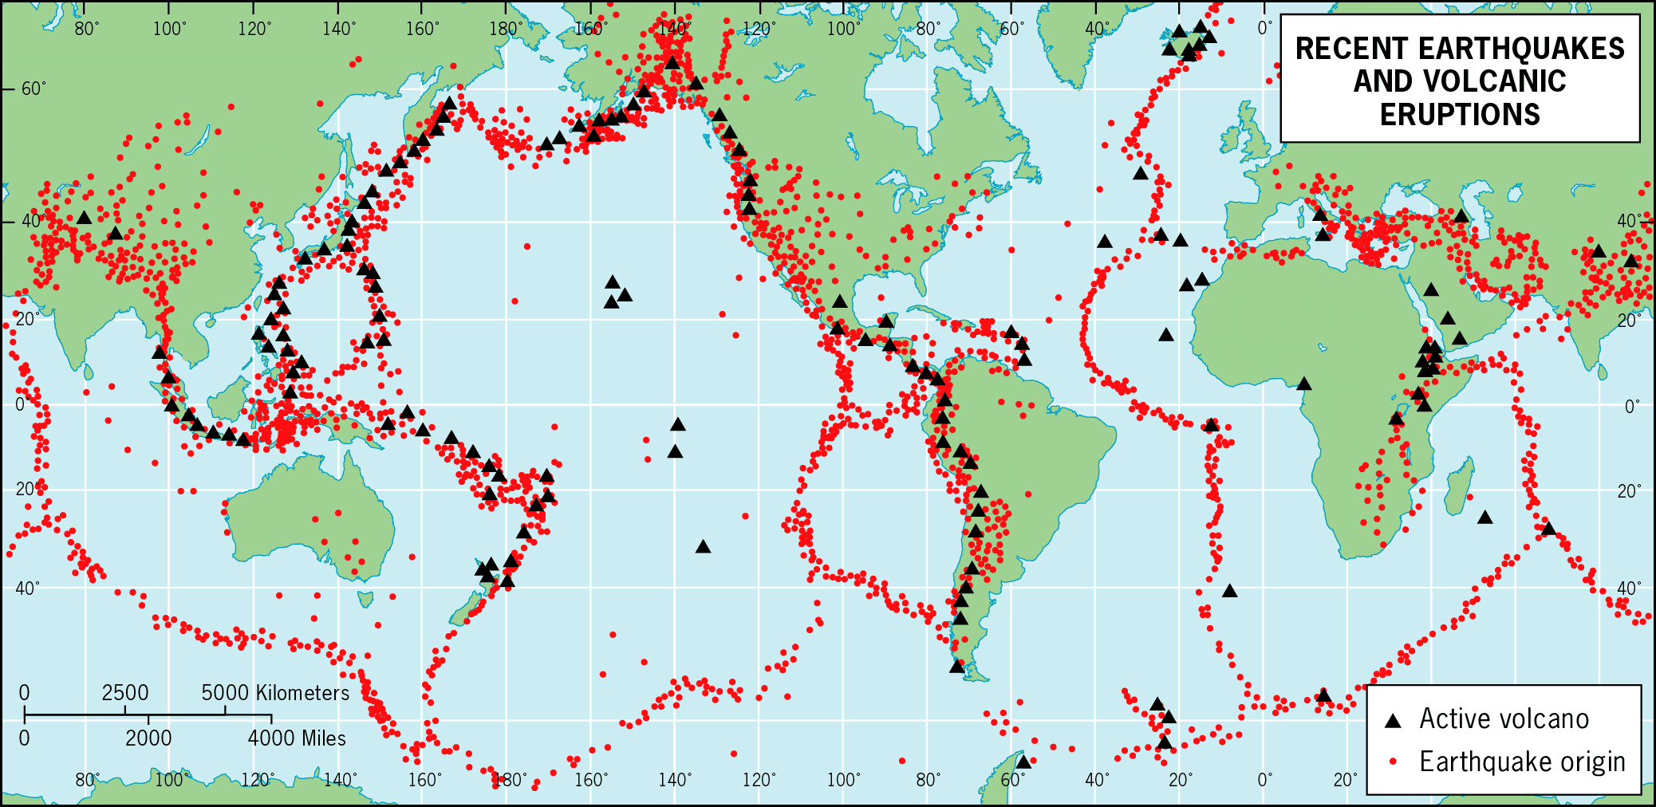
4. Explain why earthquakes and volcanoes are often located in similar locations (6)
………………………………………………………………………………………………………………………
………………………………………………………………………………………………………………………
………………………………………………………………………………………………………………………
………………………………………………………………………………………………………………………
………………………………………………………………………………………………………………………
………………………………………………………………………………………………………………………
………………………………………………………………………………………………………………………
……………………………………………………………………………………………………………………………………………………………………………………………………………………………………………………………….…………………………………………………………………………………………………………………………………………………………………………………………………………………………………………………………………………………………………………………………………………………………………………………………………………………………………………………………………………………………………………………………………………………………………………………………………………………………………………………………………………………………………………………………………………………………………………………………………………………………………………
5 - Case Study – Research

Complete research into one of the following hazards and produce a comprehensive case study with photographs and maps to support your research:

- Volcanic Eruption – Eyjafjallajokull, Iceland 2011
- Earthquake – Christchurch, New Zealand 2010 and 2011

For either hazard identify the cause, impacts (Social, Economic and Environmental) and Management of the hazard.

Landscape Systems, Processes and Change – Coastal landscape and change
Enquiry Questions:
1: Why are coastal landscapes different and what processes cause these differences?
2: How do characteristic coastal landforms contribute to coastal landscapes?
3: How do coastal erosion and sea level change alter the physical characteristics of coastlines and increase risks?
4: How can coastlines be managed to meet the needs of all players?

This topic also develops your knowledge from GCSE. Use the information below, your own knowledge AND additional research to complete the tasks below.

Coastal landscapes
The Jurassic Coastline in Dorset is one of the most famous stretches of coastline in terms of landforms and features.

6 - Your task is to research this stretch of coastline to create a case study. You will need to include photos and annotated maps to identify the different features along this stretch of coastline and start to explain how and why the different landforms are created.

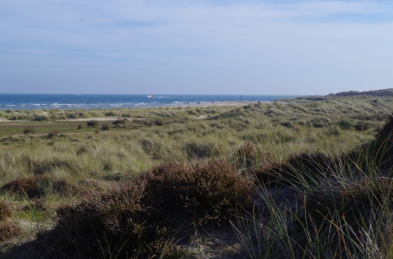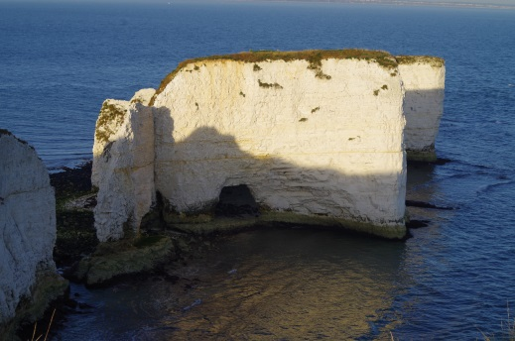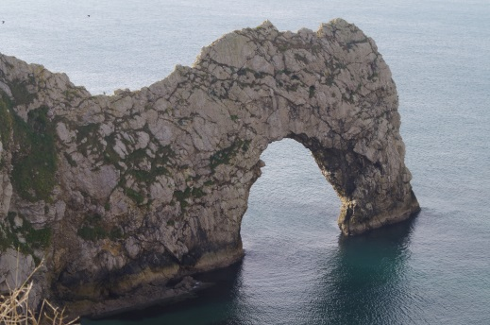

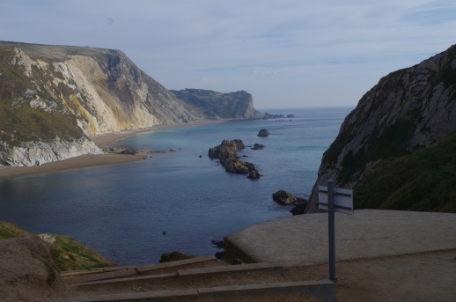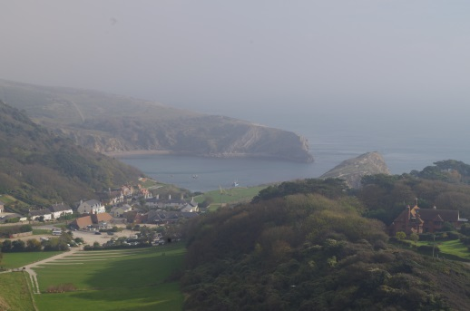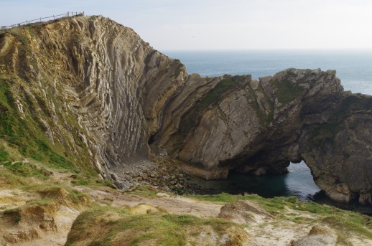

7 - Explain the relationship between geology and coastal form along the Dorset Coastline (6 marks)
……………………………………………………………………………………………………………………………………………………………………………………………………………………………………………………………………………………………………………………………………………………………………………………………………………………………………………………………………………………………………………………………………………………………………………………………………………………………………………………………………………………………………………………………………………………………………………………………………………………………………………………………………………………………………………………………………………………………………………………………………………………………………………………………………………………………………………………………………………………………………………………………………………………………………………………………………………………………………………………
Globalisation
Key information
In the last 30 years, globalisation has taken a real front seat in the concepts taught at A level geography. Changes in economy are at the forefront however changes in the environment, culture, demographics and politics of the world are also important and impact on areas at a range of scales.

Key past influences
- Since the discovery of the Americas, world trade and economy began to take shape.
- The colonialism of certain countries enabled the British Empire to control ¼ of the world bringing along British culture.
- The founding of the United Nations after the first world war allowed countries to work together easily.

Continued influences and evolution of globalisation
- Transnational Corporations (TNC): These are top firms with HQs usually in HICs however operate all over the world and are globally recognised (Coca Cola, Disney, Apple).
- Internet and IT: These have allowed design and manufacturing to be faster and easier. Jobs that typically humans would have done are now done online by less people allowing many high tech industries to be “footloose” and not reliant on being near by a resource or labour force.
- Transport: Now quicker, more efficient and low cost. The arrival of the 747 in the 1960s has revolutionised trade and movement of people.
- Growth of markets: Increase in urban living means more demand for trade, services and products.

TASK: Spiderman- a comic superhero, has been reimaged for an Indian audience.

1. Research the characteristics of this Spiderman that are Indian rather than American

2. What is the difference between economic and cultural globalisation? What does this Spiderman represent?

Global groupings
- Trade blocs: To trade easily between countries, certain agreements have been created. Examples are EU, NAFTA, CARICOM
TASK: What do the acronyms above stand for?
EU =
NAFTA =
CARICOM =
TNCs and Trade aims
- They tend to operate where labour is cheap and regulations are lacking
- To gain government grants from countries that are attracting new business
- They operate inside local trade barriers and avoid tariffs
- They like to be near markets
Positives to TNCs
- Raising living standards – TNCs invest in the economies of many NICs and LICs
- Transfer of technology – south Korean firms e.g. Samsung have learned to design products for foreign markets
- Political stability – investment by TNCs has contributed to economic growth and political stability e.g. China
- Raising environmental awareness – due to large corporate image TNCs do respond to criticism e.g. Starbucks have their sustainability campaign

Negatives to TNCs
- Tax avoidance – many avoid paying full taxed in countries they operate in through concessions, e.g. Starbucks and Amazon
- Limited linkages – FDI does not always help developing nations economies
- Growing global wealth divide – selective investment in certain global areas is creating a widening divide e.g. Southeast Asia vs. sub-Saharan Africa
- Environmental disaster and destruction – example of Bhopal, India disaster in 1984

TASKS
Create an annotated photo of either your family car or your living room with the various places where the parts/ features were manufactured

Choose an example of a TNC and create a timeline of events since their foundation as a company. What have been the benefits that the company has brought to the countries involved. Examples could be Nike, Mattel, Disney or Tesco.

Networks and hubs
The term ‘global network’ refers to links between different countries in the world, this includes – flows of capital, traded goods, services, information (and people). Some areas are well connected i.e. high income areas, others poorly i.e. low income areas.

- A network is a model that shows how places are linked together. E.g. London Underground.
- A global hub is used to describe a place which is especially well connected. Connections between these hubs are called flows and include:
- Money- as major capital flows are routed through global stock markets
- Raw materials - e.g. food and oil traded between nations
- Manufactured goods and services - value of world trade is $70 trillion
- Information - internet has brought real-time communication between distant places
- People - movement of people still an issue due to border controls and immigration law

TASK
Create a case study of Easyjet- an example of a shrinking world. Include some background information, role of technology and current impact of the company.

Being switched off
- Many countries in the world are unable to access global networks
- Specific conditions have caused them being switched off

Physical | Human
- Poor soil for farming  - No coastline puts investors off as trade is harder  - Vulnerability to hazards and climate change | - Low skills of the population  - Poor literacy rates  - Politically instability  - Civil war

Regenerating places
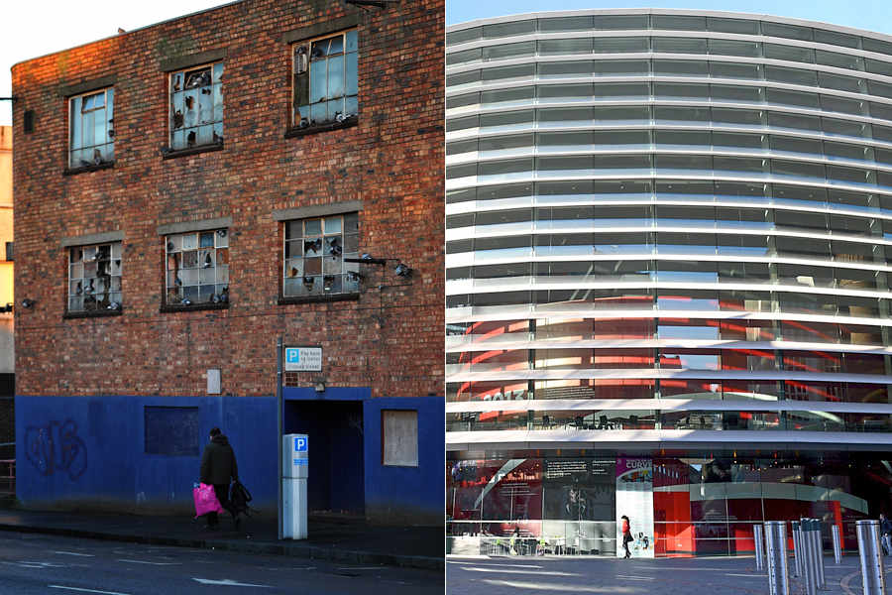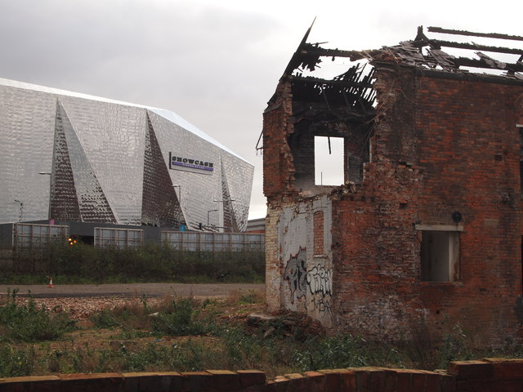
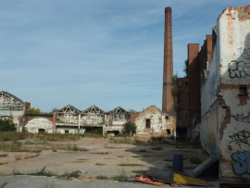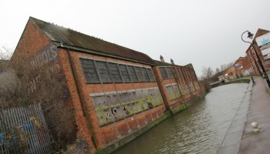
You will study four enquiry questions whilst exploring ‘Regenerating Places’ -
- How and why do places vary?
- Why might regeneration be needed?
- How is regeneration managed?
- How successful is regeneration?

HOW AND WHY DO PLACES VARY?
In this first enquiry question, you are expected to undertake an in-depth study of the local place in which you live or study (which will be Leicester) and one contrasting place (possibly Mumbai or Rio de Janeiro).
Your task is to complete secondary research on your local place, Leicester, to focus on enquiry questions 2 and 3.
ENQUIRY QUESTION 2: WHY MIGHT REGENERATION BE NEEDED?
Why did Leicester need to be regenerated?
Use the internet, local libraries, the Records Office and your own knowledge to find out why Leicester needed to be regenerated. You need to consider a wide range of questions and find out if they applied or apply to Leicester, such as;
- Has the city experienced deindustrialisation?
- Have industries closed down and for what reasons?
- What was/is the level of unemployment?
- Are there skills shortages?
- Has the area experienced outward migration?
- What has happened to property prices?
- Does the area suffer from social deprivation (health, education, crime and access to services)?
- Is there any evidence of sink estates, commuter villages or declining rural settlements?
- Are local communities engaged in the area (consider election turnout and local community groups)?
- What is the ethnic mix/make-up of the area?
- What is the population structure of the area?
- Are there many new residents (students, in-migrants)?
- Is there evidence of conflict between different groups within communities?
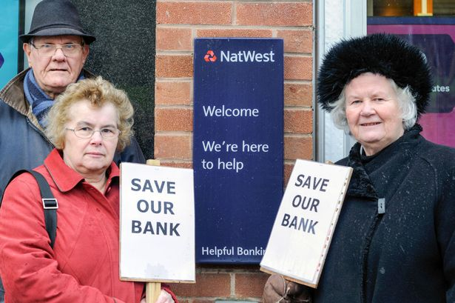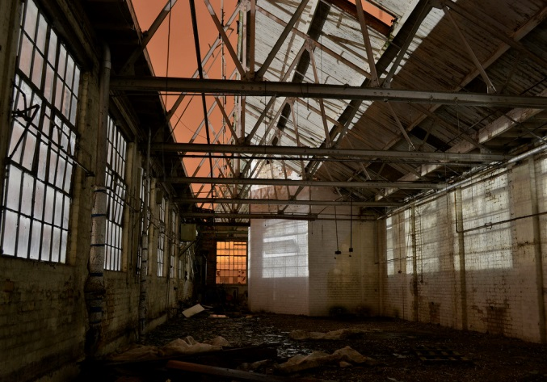

ENQUIRY QUESTION3: HOW IS REGENRATION MANAGED?
Has national government made any policy decisions that have had an impact on Leicester’s regeneration? i.e.:
- Have they developed local airports?
- Have they improved transport infrastructure?
- Have they passed new planning laws?
- Have they set house building targets?
- Have they made decisions about international migration?
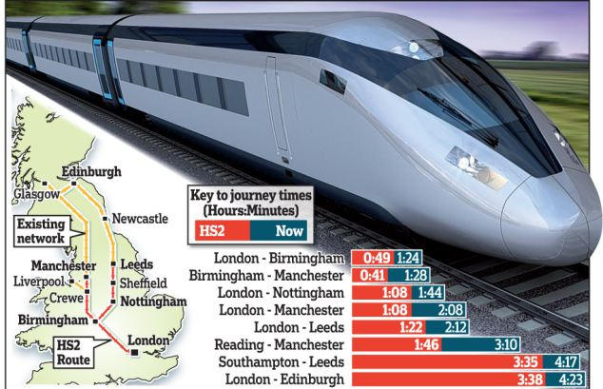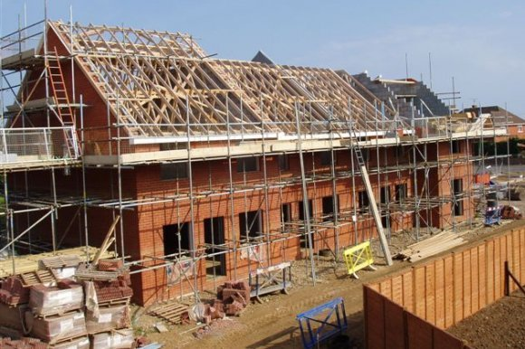
Has local government taken decisions to make the area look more attractive to inward investors?
- Have they created science parks, industrial estates to attract new firms to the area?
- Are local interest groups (Chamber of Commerce, preservation societies) involved in the key decision-making process in the area?
- Have they been involved in any leisure and tourism, retail or sport strategies to regenerate the area?
- Have they encouraged rural diversification?
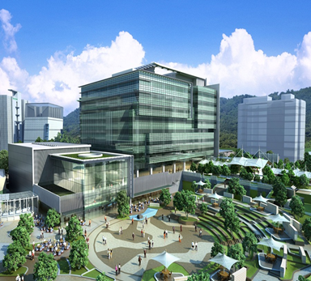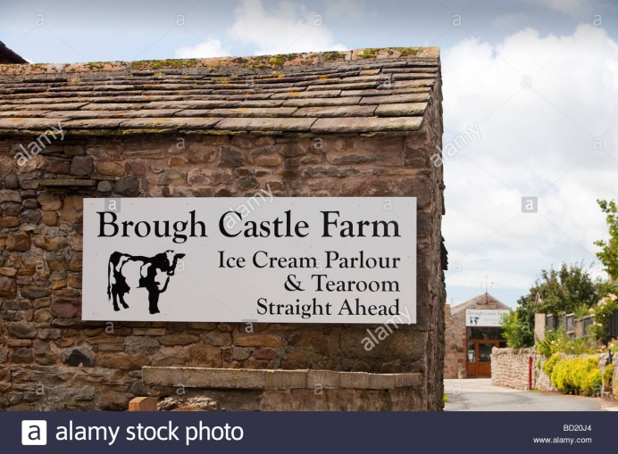

Has rebranding taken place to change the public’s perception of the area?
- Has the area experienced any urban or rural rebranding?
- Has the urban area been rebranded around industry, culture, heritage or sport?
- Has the rural area been rebranded around specialist products, outdoor pursuits, heritage or film?
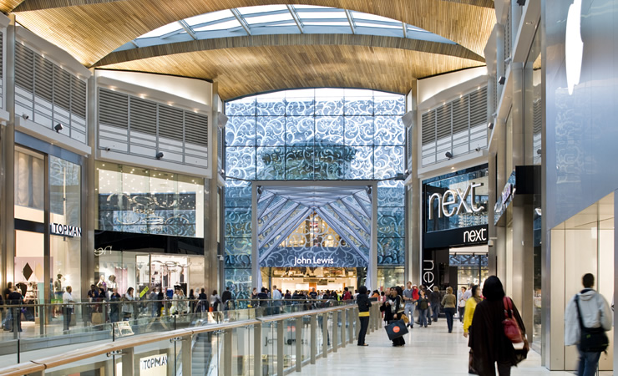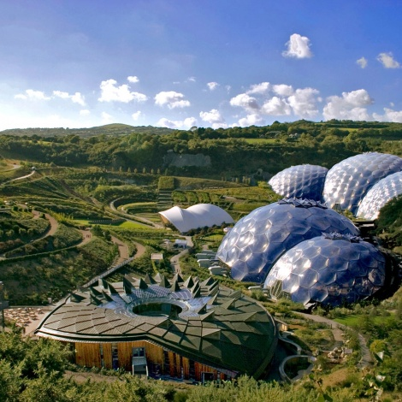
REGENERATING PLACES GLOSSARY
Complete the glossary, remembering that the terms are all related to regenerating places, in either urban or rural areas.
- Area based incentives
- Cold spots
- Community groups
- Commuter villages
- Deindustrialisation
- Demographic changes
- Depopulation
- Deprivation
- Environmental inequality
- Flagship regeneration projects
- Gated communities
- Gentrification
- Glasgow effect
- High Speed Two (HS2)
- Index of Multiple Deprivation (IMD)
- Indicators of success
- Legacy
- Levels of engagement
- Lived experience
- Local Enterprise Partnership (LEP)
- Marginalisation
- Not In My Back Yard (NIMBY) groups
- Postcode lottery
- Rebranding
- Regeneration
- Regeneration strategies
- Re-imaging
- Re-inventor cities
- Replicator cities
- Rural – urban continuum
- Rural proofing
- Service inequality
- Sink estate
- Social inequality
- Social polarisation
- Social segregation
- Spiral of decline / De- multiplier effect
- Studentification
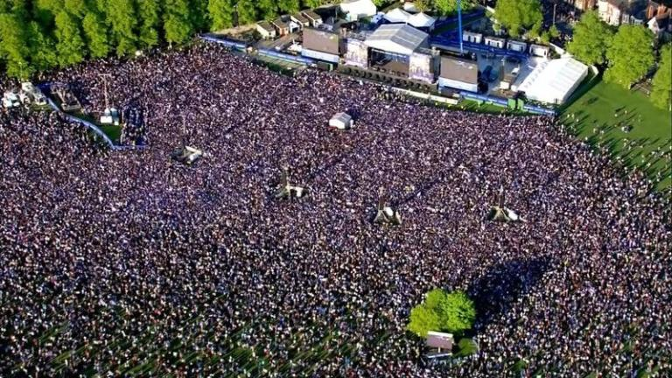
ASSESSMENT: EXAM STYLE QUESTION
(a) Explain reasons why a place you have studied needed to be regenerated. (6 marks)
……………………………………………………………………………………………………………………………………………………………………………………………………………………………………………………………………………………………………………………………………………………………………………………………………………………………………………………………………………………………………………………………………………………………………………………………………………………………………………………………………………………………………………………………………………………………………………………………………………………………………………………………………………………………………………………………………………………………………………………………………………………………………………………………………………………………………………………………………………………………………………………………………………………………………………………………………………………………………………………………………………………………………………………………………………………………………………………………………………………………………………………………………………………………………………………………………………………………………………………………………………………………………………………………………………………………………………………………………………………………………………………………………………………
(b) Explain how local government can have an impact on regeneration. (4 marks)
………………………………………………………………………………………………………………………………………………………………………………………………………………………………………………………………………………………………………………………………………………………………………………………………………………………………………………………………………………………………………………………………………………………………………………………………………………………………………………………………………………………………………………………………………………………………………………………………………………………………………………………………………………………………………………………………………………………………………………………………………………………………………………………………………………………………………………………………………………………………………………………………………………………………………………………………………………………………………………………………………………………………………………………………………………………………………………………………………………………………………..

