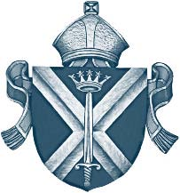
Diocese of St. Albans

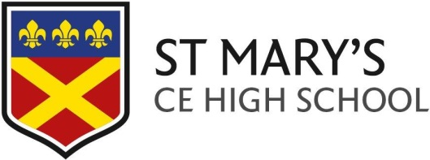

July 2023

Dear Parents / Carers

As we approach the end of the academic year 2022/2023, I know thoughts will be turning to getting ready for September. To avoid making expensive mistakes with choices of uniform, jewellery, phones, etc., please read the details below. We will resend the same letter in mid-August and again on 1 September to act as reminders for you, because I know how busy family life is!

Road safety
One of our students was knocked down by a vehicle in Theobalds Lane recently. The students who were nearby were mature and behaved fantastically responsibly until school staff and parents arrived. Thankfully, the student only suffered minor injuries, but it could have been far worse. I will not go into details about what caused the accident, but please discuss road safety with your children and remind them that they need to concentrate on what they are doing, they should not wear ear phones/pods/buds that prevent them from hearing traffic and they should not play games such as ‘IT/Tag’ or football in or near the road. If they cycle they must observe the highway code and should wear a helmet.

School Uniform arrangements from September 2023

We are writing to remind you with our uniform expectations from September 2023. We all share exceptionally high expectations of our students with regard to their uniform and promote a formal, professional learning environment. Wearing our uniform with pride shows that we care and we belong to the St Mary’s CE High School.

For more information on all school uniform requirements including shoes, hair, jewellery and accessories, please visit our school website. If you are unsure whether a piece of uniform is acceptable, please consult the school before buying.

Additional reminder about acceptable school shoes
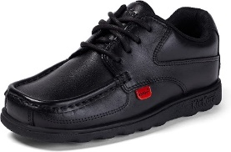
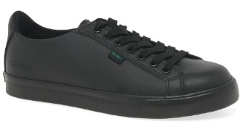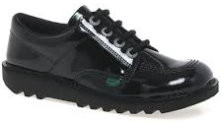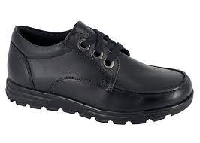
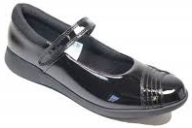
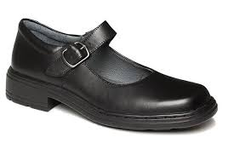
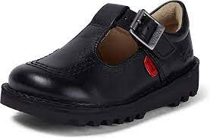
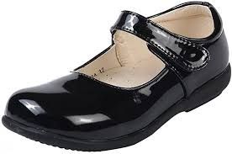

No boots, canvas shoes or trainer style shoes are permitted, including branded sports makes including (but not limited to) Nike, Adidas, Converse, Stan Smiths and Vans. Please see below examples of prohibited shoes:

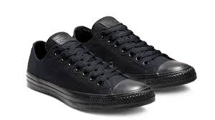
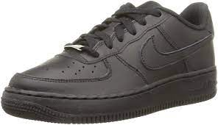
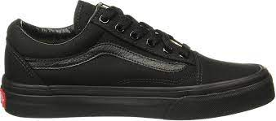
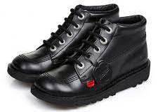

If you have any outgrown uniform that you are able to donate to the school for this then please bring items to Reception. The school will be in touch with all parents/carers to provide further information.

We rely upon the support of parents/carers in maintaining our high expectations regarding uniform. If a student is wearing incorrect uniform, we will work with parents/carers to resolve this as soon as possible. Thank you for your support.

https://st-maryshigh.herts.sch.uk/wp-content/uploads/2022/03/Uniform-Personal-Presentation-Policy-rev-Spring-22.pdf

The official School Uniform Suppliers are as below.
- Smiths Schoolwear 155 – 157 Lancaster Road, Enfield EN2 0JN, UNITED KINGDOM – Tel 0208 363 2424
- Contact Us | Smiths Schoolwear

Mobile phones

Students may bring a basic mobile phone/s (calls and texts only) to school for use to and from school as required. However, this phone must not be a smart phone which we define as a mobile phone that performs many of the functions of a computer, typically having a touchscreen interface, internet access, a camera and an operating system capable of running downloaded apps. Please note that once inside the main school building, the School operates a “no mobile” policy. This means that all mobile phones and electronic devices:

https://st-maryshigh.herts.sch.uk/wp-content/uploads/2022/09/B4L-Mobile-Phone-Electronic-Items-Use-Policy-Autumn-2022.pdf

Fully equipped pencil case

This is a reminder that students need to come to school with a fully equipped pencil case. A full list of all the items required by students is shared to them during weekly reminder in tutor time as well as Act of Worship, and it includes a READING BOOK, a PENCIL, a, PEN (including a green pen) RULER and a CALCULATOR.

Students need all the above named equipment during their tutorial. Failure to produce all necessary equipment will result in a C2 sanction. Persistent failure to produce basic equipment will carry further sanctions. Many thanks for your support in ensuring your child arrives at school with the required basic equipment.

Water bottle

Please make sure your child brings water to school and make sure it is in a clear bottle. Water bottles can be refilled during social times from outlets in the dining hall.

Term dates 2023 – 2024

Finally, a reminder of the Term Dates for 2023-2024 are below and on the website:

Autumn Term 2023
Mon 4 Sept – Staff CPA
Tues 5 Sept – Inset day – Year 7 and Year 12 students only
Wed 6 Sept - Whole school autumn term starts
Fri 20 Oct – Staff CPA
HALF TERM – Mon 23 – Fri 27 Oct
Fri 24 Nov – Staff Occasional day (school closed)
Fri 15 Dec – End of autumn term. Students depart 12.30pm
CHRISTMAS – Mon 18 Dec – Tues 2 Jan 2024

Spring Term 2024
Wed 3 Jan – Staff CPA
Thurs 4 Jan - Whole school spring term starts
HALF TERM – Mon 19 Feb – Fri 23 Feb
Thurs 28 March – end of Spring term. Students depart 12.30pm
EASTER – Fri 29 March – Fri 12 April

Summer Term 2024
Mon 15 April – Staff CPA
Tues 16 April - Whole school summer term starts
Mon 6 May – BANK HOL
HALF TERM – Mon 27 May – Fri 31 May
Fri 19 July – End of summer term and school year. Students depart 12.30pm

Yours faithfully
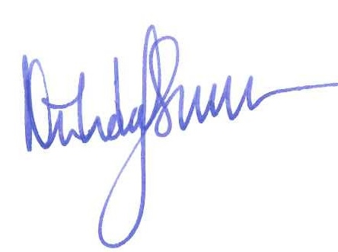

Nicholas Simms
Head Teacher

